This document is to assist you in requesting a Research Participant Advance. A Research Participant Advance is to be used to provide compensation to participants in your research study.
Please Note: if payments made to individual participants are $500.00 or more in a calendar year the department is responsible for collecting information so a T4A can be issued. The information needed includes full legal name, home address and Social Insurance Number. This information must be provided to Financial Services in a secure manner by the first week in January of the following the calendar year.
The Research Participant Advance cannot be used for travel or other expenses. It must be submitted using a research project number and can only be used for payments to participants in a research study.
NOTE: Some projects refer to research participant payments as honorariums. When processing the request and the claim please clarify that these are research participant payments and not the typical “honorarium”.
Cash Advance for Research Participant Payments
- Log into ERS (for more information see the First Time ERS Users Guide):
www.queensu.ca > Search and Sign In > My Queen’sU – SOLUS, MyHR and more > Expense Reimbursement
- Go to the Expense Tab the click on Cash Advances.
- Click on the red “Request Cash Advance” box:
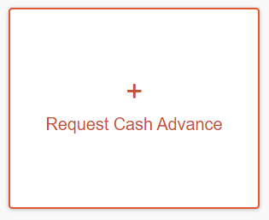
- A new window will open and enter in all information marked with a red star:
  - Cash Advance Name – Your project name or the format preferred by your department or the project.
  - Cash Advance Amount – The total needed for the Research Participant Payments.
  - Business Purpose – Your department may have a format they want used.
  - Start Date and End Date – It is understood that this may be a long period.
  - You will have to enter in a research project code. If you do not know the code or are unsure, you will have to work with your department or contact Research Accounting (research.accounting@queensu.ca) for confirmation.

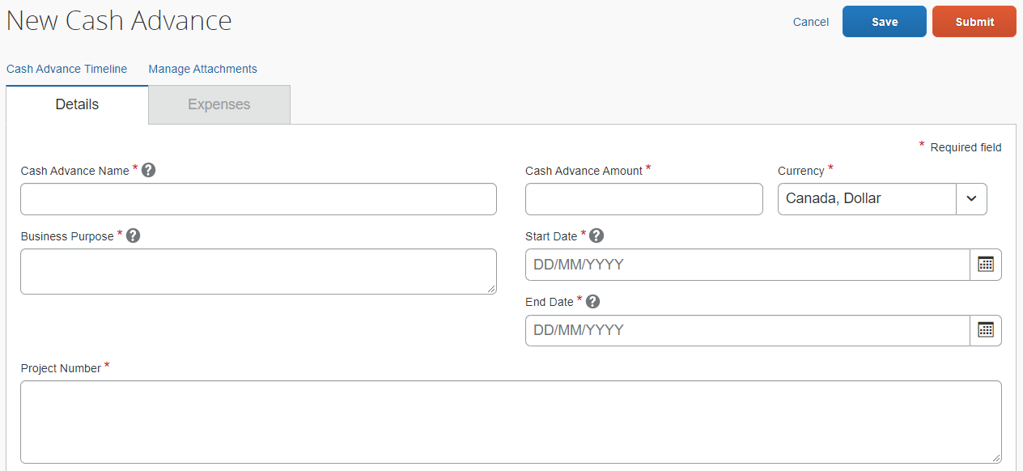

- Go to the Cash Advance Timeline link:

- The Cash Advance Timeline window will open.
- Beside Approval Flow you will see an “Edit” button, select it:

- A new window will open showing “Approval” flow.
- In the Cash Advance Approval box, search for your approver by last name.
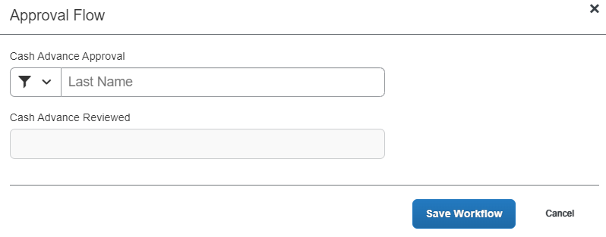
- Select their name from the drop-down list, then “Save Workflow”.
- You will be taken back to the Cash Advance Timeline window, in the bottom right corner select the “Close” button to be taken back to the Request.
- Select the orange “Submit” button in the bottom right corner.
- A window will open showing that the request has been submitted.

Checking Status of Research Participant Advance Request
- Under the Expense Tab go to the Cash Advance Drop down menu.
- Select the “View Cash Advances” option.
- The status will show you where the request is:
  - Pending Approval: Your approver has not looked at and approved the request yet.
  - Pending Expense Cash Advance Administrator: The request is with Financial Services for final review and approval.
  - Issued: The request has been approved and sent for payment. Payments are processed every Tuesday and Thursday.

For more information or assistance using the ERS, please contact expenses@queensu.ca

